**TITLE:**Analyse and Implement the solution for recursively finding the Maximum and Minimum element using Divide and Conquer Strategy.

**AIM:**Given an Array of Integers, find Minimum and Maximum element present in it with minimum number of comparisons by using Divide and Conquer Strategy.

**OUTCOME:**

After successful completion of this experiment students will be able to,

1. Analyze the Divide and Conquer Strategy.
2. Understand and Implement program to recursively find the Maximum and Minimum element in an Array using Divide and Conquer Strategy.

**THEORY:**

**Divide & Conquer Strategy:**

In this approach, the array is divided into two halves. Then using recursive approach maximum and minimum numbers in each halves are found. Later, return the maximum of two maxima of each half and the minimum of two minima of each half.

In this given problem, the number of elements in an array is *y*−*x*+1, where **y** is greater than or equal to **x**.

*Max*−*Min(x,y)*will return the maximum and minimum values of an array*numbers[x...y]*.

**ALGORITHM:**

**Max - Min(x, y)**

if y – x ≤ 1 then

   return (max(numbers[x], numbers[y]), min((numbers[x], numbers[y]))

else

   (max1, min1):= maxmin(x, ⌊((x + y)/2)⌋)

   (max2, min2):= maxmin(⌊((x + y)/2) + 1)⌋,y)

return (max(max1, max2), min(min1, min2))

**INSTRUCTIONS FOR STUDENTS:**

1. Implement Algorithm in Python
2. Copy and Paste Code as well as Output in following section.
3. Compute Time and Space complexity of Algorithm.
4. Write Conclusion.
5. Answer all the Questions.

**SOURCE CODE:**

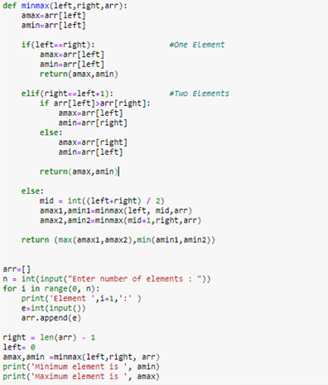

**INPUT AND OUTPUT:**

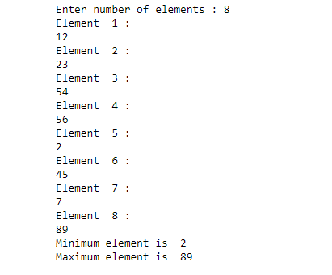

**CONCLUSION:**

In this experiment we learnt about Divide and conquer strategy and also implemented the algorithm successfully. We also got to know how this approach is better than Naïve method as this algorithm takes less comparisons than the naïve method

**QUESTIONS:**

Q.1. Explain Divide and Conquer Strategy.

In this approach, the array is divided into two halves. Then using recursive approach maximum and minimum numbers in each halves are found. Later, return the maximum of two maxima of each half and the minimum of two minima of each half.

This technique can be divided into the following three parts:

Divide: This involves dividing the problem into some sub problem.

Conquer: Sub problem by calling recursively until sub problem solved.

Combine: The Sub problem Solved so that we will get find problem solution.

Q.2. What is Naïve or Straightforward Method for finding Minimum and Maximum element present in an Array?

We initialize both minimum and maximum element to the first element and then traverse the array, comparing each element and update minimum and maximum whenever necessary.

Q.3. Compute Time complexity of Naïve or Straightforward Method.

Whenever In every loop we are doing 2 comparisons in worst case

Therefore, 2*(n-1)= 2n-2

Neglecting constant terms ,

Time Complexity= O(n)

Space Complexity=O(1)

Q.4. Compute Time complexity of Recursive Algorithm for finding the Maximum and Minimum element using Divide and Conquer Strategy.

3n-2= O(n)

Q.5. Compare and Contrast Naïve versus Recursive Method.

A Naive algorithm is usually the most obvious solution when one is asked a problem. It may not be a smart algorithm but will probably get the job done

The process in which a function calls itself directly or indirectly is called recursion and the corresponding function is called as recursive function. Using recursive algorithm, certain problems can be solved quite easily.